Implementation Report

Overview of Environment Setup
DriveEase is a hypothetical car rental management system that manages customers, vehicles, rental locations, reservations, rentals, payments and maintenance records. This phase builds on the database model developed in Phase 1 by implementing the relational database in PostgreSQL, populating it with synthetic data and developing queries that support business operations and reporting. The project also includes a firestore database that stores detailed vehicle damage and repair logs.
Screenshots verifying successful execution in Firestore
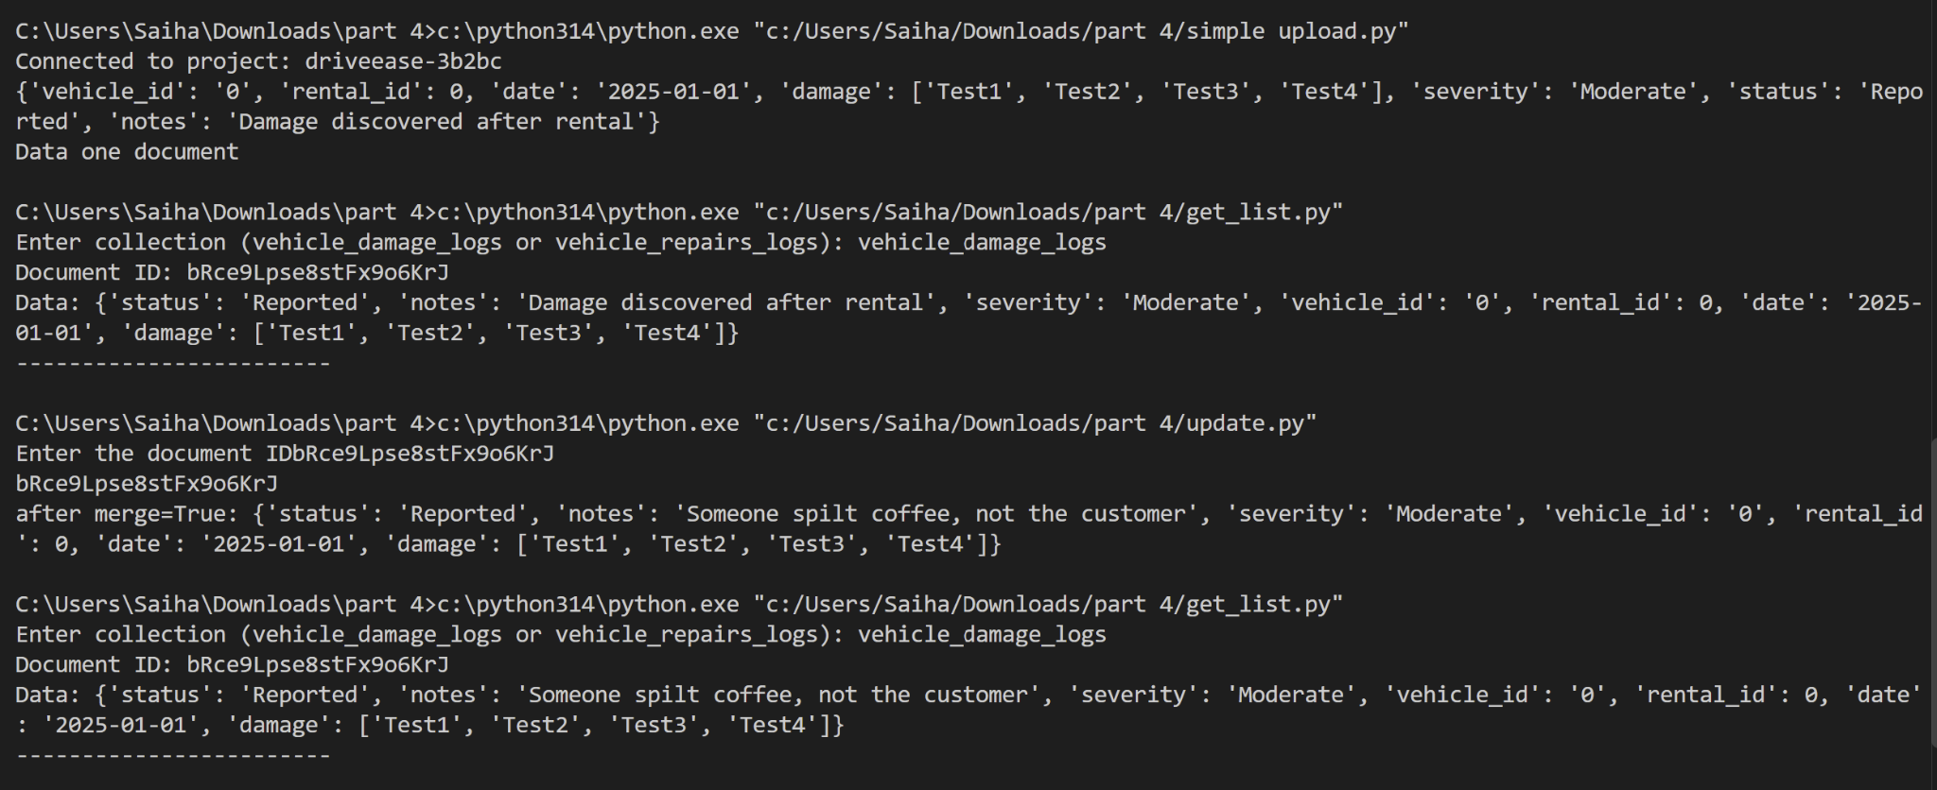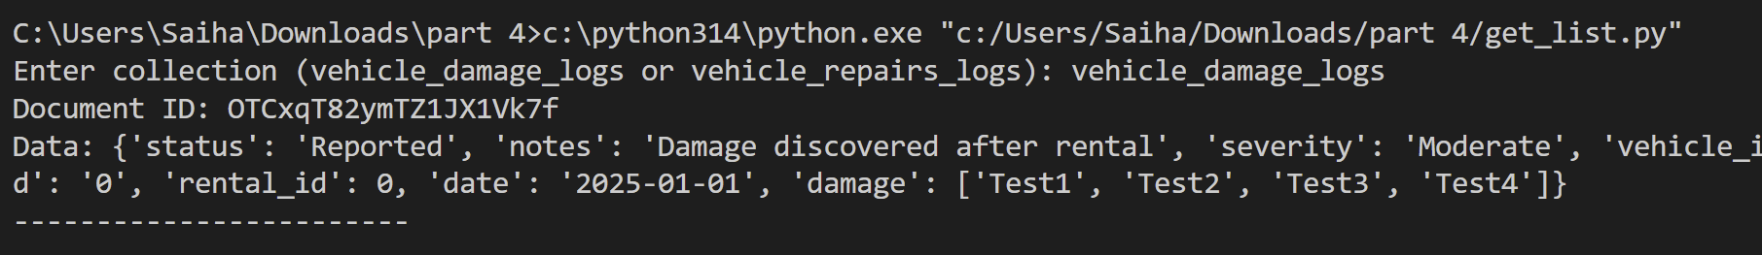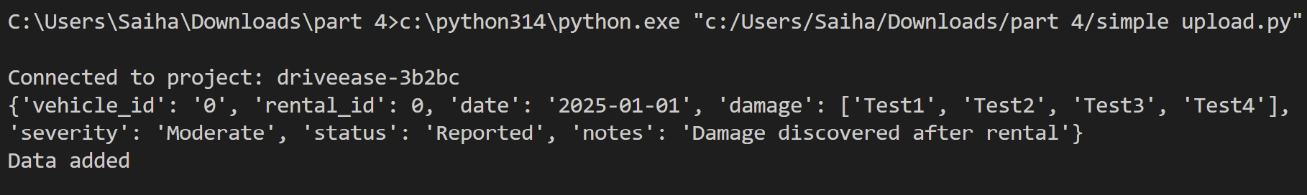
Screenshots verifying successful execution in Firestore
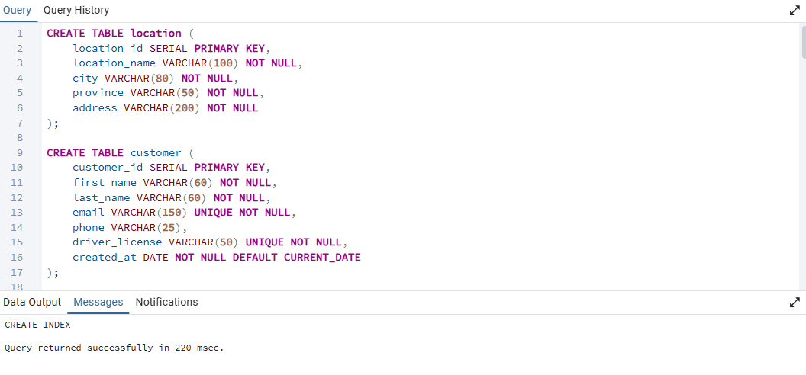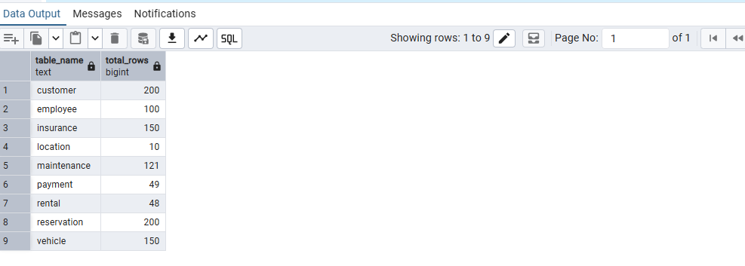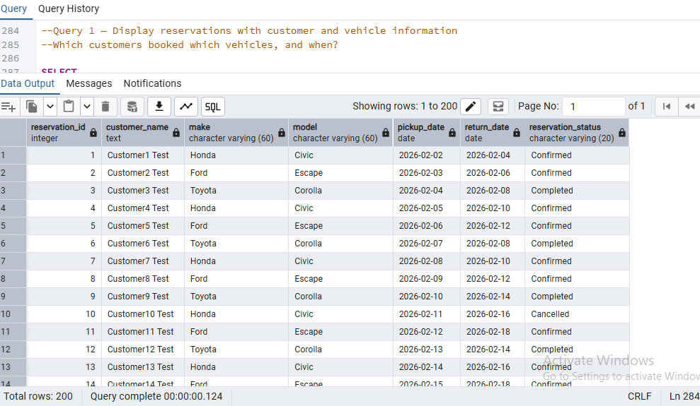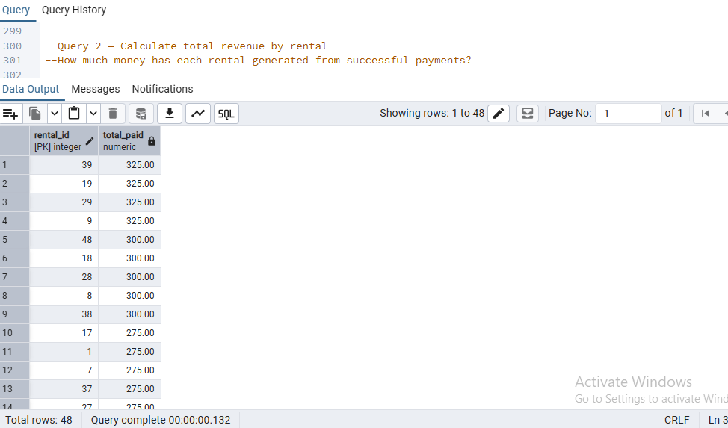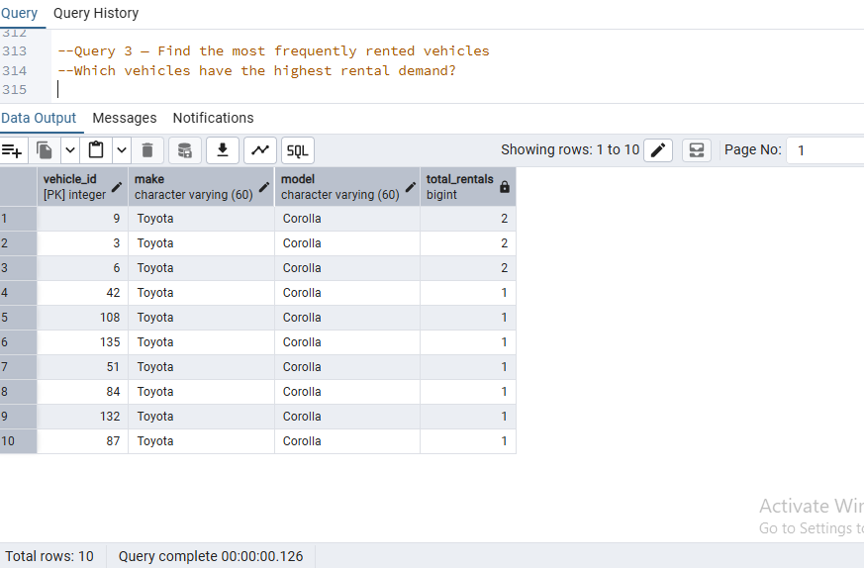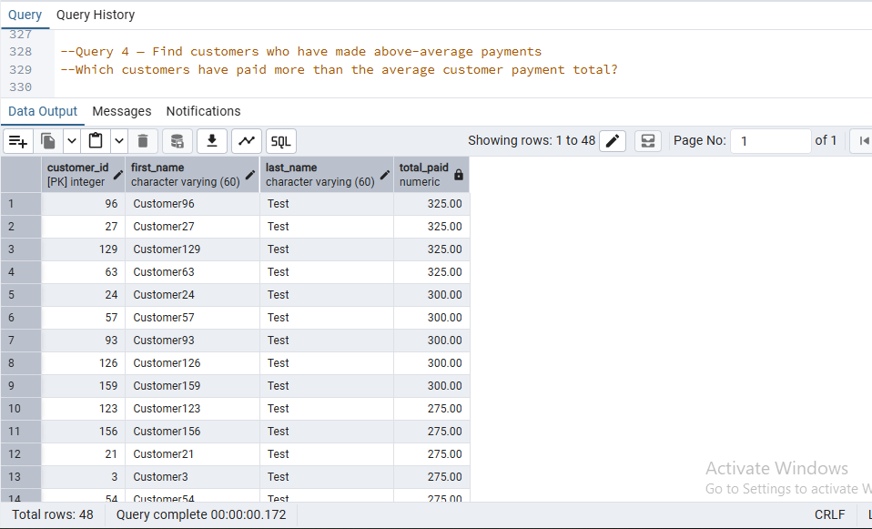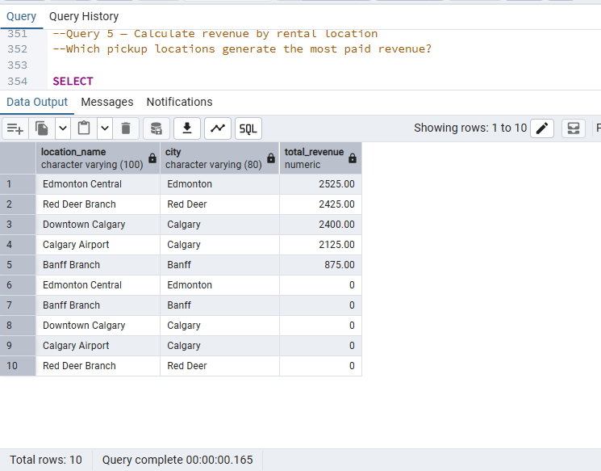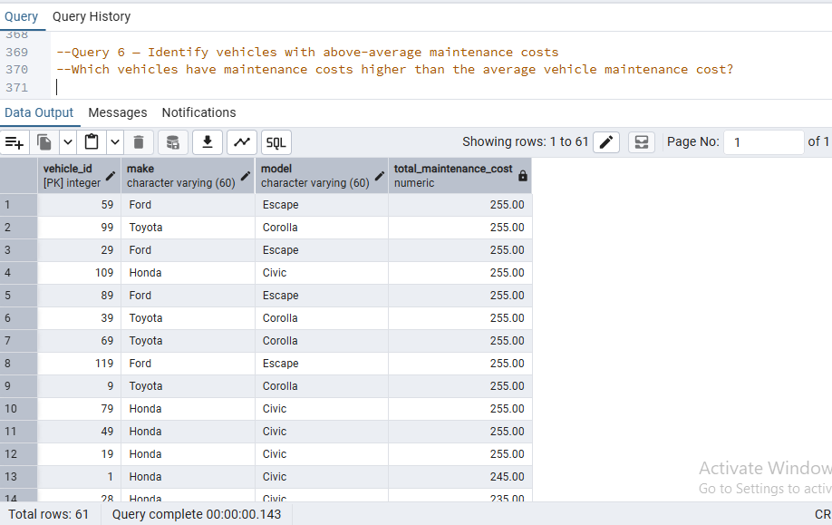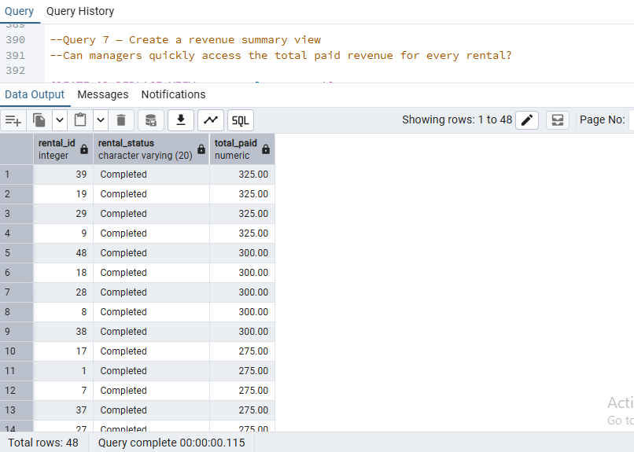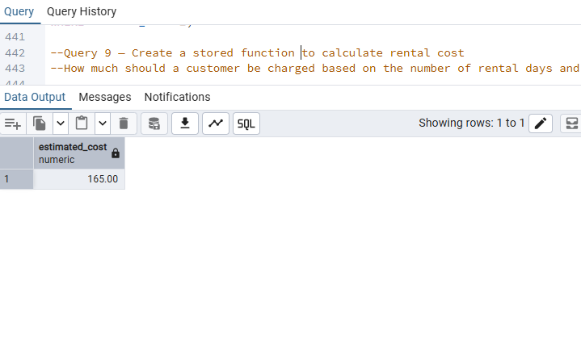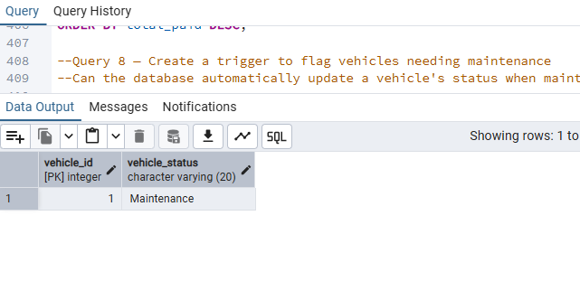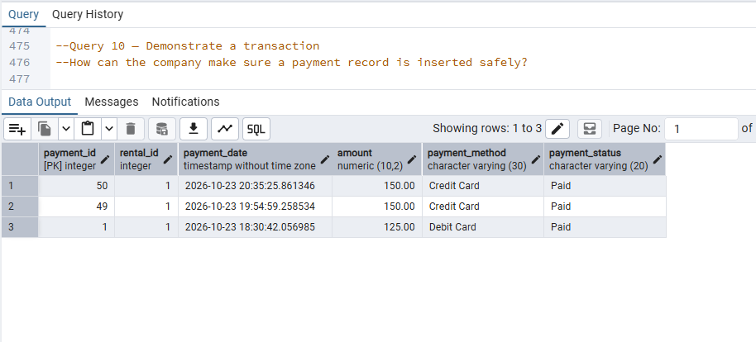

Team Contributions
Team Member | Contribution
Saihaj
Kyle | Assisted with section 4 and Prepared the implementation report.
Vivek
Nathan

